Reducing Food Wastage by Analyzing Restaurants Takeaway Orders Dataset

Locations of important files and datasets:

* Datasets can be found under the **Datasets** folder
* Jupyter Notebook runnable file is inside **ipynb-Jupyter Notebook** folder
* Power BI runnable file can be found inside **pbix-Power BI** folder.

How to run the ipynb file:

* Install Anaconda Navigator from here:

<https://sparkbyexamples.com/python/how-to-install-anaconda-on-windows>

Installation guide for Anaconda Navigator: <https://docs.anaconda.com/anaconda/install/>

* Install findspark, pyspark, and Java from this link:

<https://sparkbyexamples.com/spark/apache-spark-installation-on-windows/>

installation tutorial for spark: <https://sparkbyexamples.com/spark/apache-spark-installation-on-windows/>

* From Anaconda Navigator open Jupyter Notebook. After that open the directory where the ipynb file is saved. Now load the file in the Jupyter Notebook text editor.
* Download MongoDB from here: <https://www.mongodb.com/docs/manual/installation/>
* Download Studio 3T from here:

<https://studio3t.com/download>

* Connect Studio 3T with MongoDB using this guide: <https://studio3t.com/knowledge-base/articles/connect-to-mongodb/>
* Download PowerBI from this link: <https://powerbi.microsoft.com/en-au/getting-started-with-power-bi/>
* A picture containing text

  Description automatically generatedIn section 3 of ipynb file, put the directory where restaurant-1-orders and restaurant-2-orders are saved.
* A picture containing text

  Description automatically generatedIn section 12, put the directory where restaurant-1-ingredients and restaurant-2-ingredients datasets are saved.
* Graphical user interface, text, application

  Description automatically generatedIn section 19 and 20, put your desired local directory where you want to save the restaurant-1-details and restaurant-2-details datasets.
* 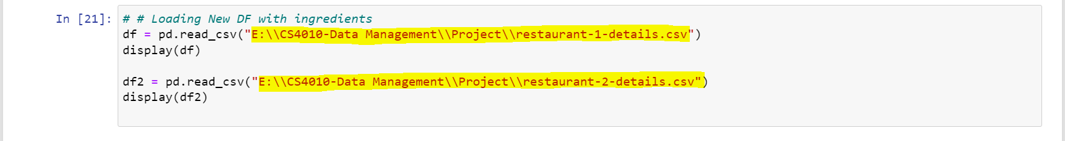In section 21, put the directory where you saved restaurant-1-details and restaurant-2-details datasets.
* **Tips:** You can skip by commenting out section 17-20 as it will take a lot of time for data entry. You can use the attached dataset named restaurant-1-details and restaurant-2-details for loading the restaurant orders with ingredients. However, you must change the directory according to your saved location.

Load pbix file:

* To load the Power BI file, go to **pbix-Power BI** folder and open the pbix file.

Load pbix file from scratch:

This is the procedure of how we connect our Power BI with MongoDB (Studio 3T).

* To connect MongoDB with Power BI, we used the Simba ODBC driver which can be found here:

<https://www.magnitude.com/drivers/mongodb-odbc-jdbc?utm_source=google&utm_medium=search&utm_campaign=si-se-Drivers-RTU-2022&utm_content=121468984489&gclid=Cj0KCQjwmouZBhDSARIsALYcourDfv-jCtEEHgtGZ_mxVF_UTMvy6VtdL3MncMVR0Dsc-n7UOJBu6KYaAp0yEALw_wcB>

* You will receive and email for simba ODBC license. Download the license and paste it under C:\Program Files\Simba MongoDB ODBC Driver\lib directory. The license file should look like this,



* After downloading and Installing Simba ODBC create a system DSN like the figure given below,

* Now open Power BI and select ODBC then click connect

* Select the DSN that you have created, in my case it is BigData

* Now you can find all the datasets in Power BI which were in MongoDB

